AWS Automation with Lambda & Boto3
_____________________________________________________________________________________________________
Automated S3 Bucket Cleanup (Objects Older Than 30 Days)
Objective: Automate deletion of stale objects in an S3 bucket.
Task: Delete files older than 30 days in a specific bucket.
----------------------------------------------------------------------------------------------------------------------------------------

Step 1 – Create an S3 Bucket
- Login to AWS Console.
- Open S3.
- Click Create Bucket.
- Enter:
Bucket Name:
- mys3demo-123456
- Leave all defaults.
- Click Create Bucket.
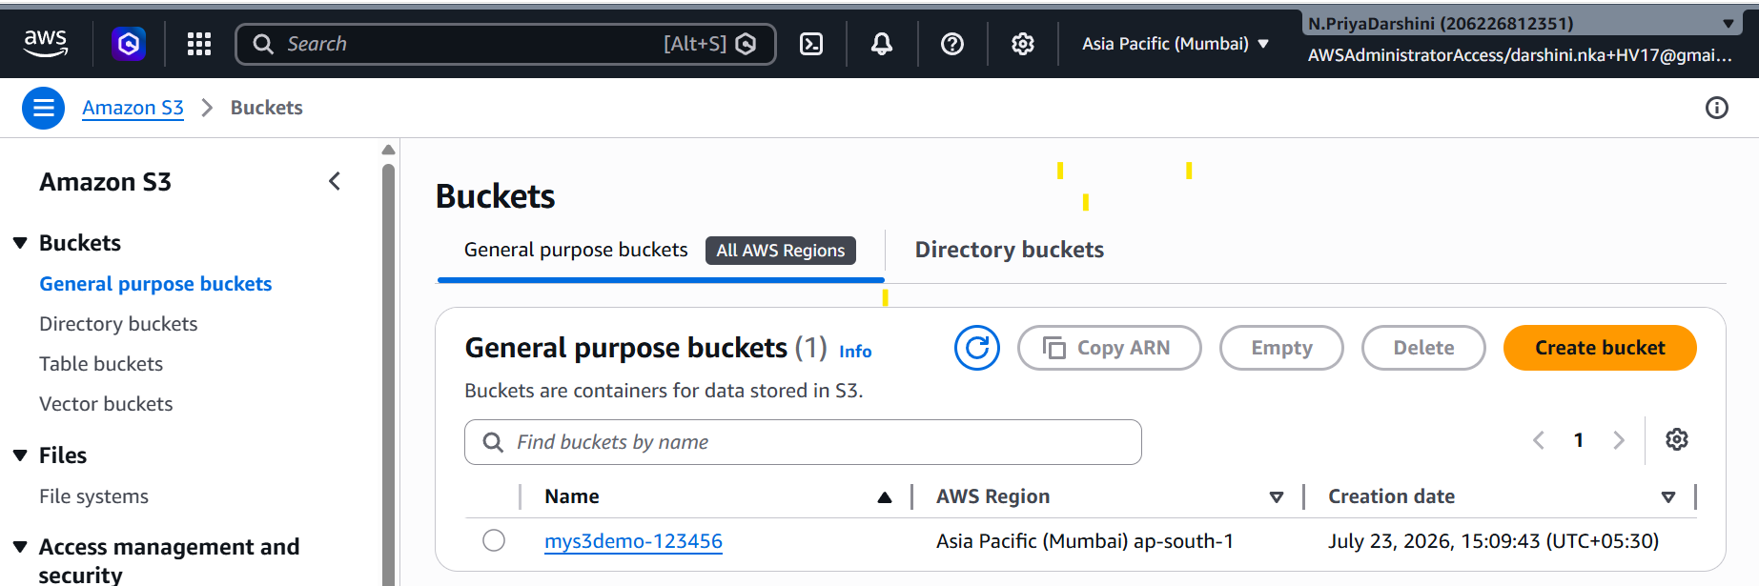

Step 2 – Upload Sample Files
Open the bucket.
Upload multiple files such as:
sample1.txt
sample2.txt
sample3.txt
image.png
notes.pdf
Since new uploads are not 30 days old, testing with a 30-day threshold isn't practical.
For testing:
Use a 5-minute threshold.
Later change it back to 30 days.

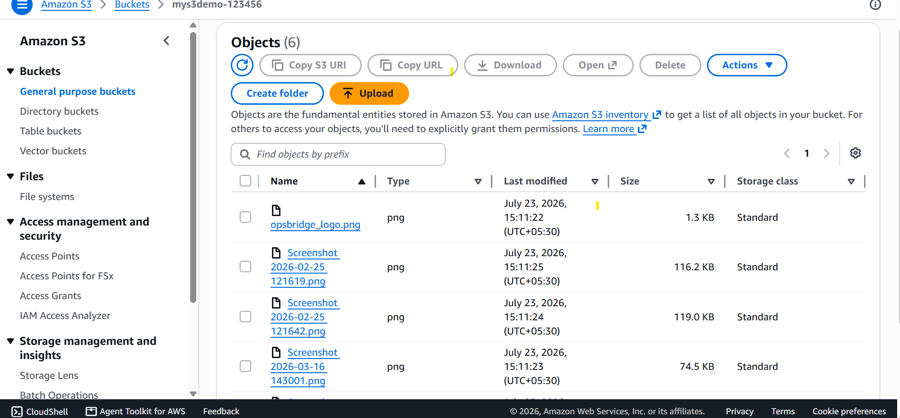

Step 3 – Create IAM Role for Lambda
Go to
IAM
→ Roles→ Create Role
Trusted Entity:AWS Service
Choose Lambda. Click Next.
Role Name:
S3CleanupLambdaRole
S3CleanupLambda-role-fa4q8eq9

Create the role with the Cloudwatch policy.

Step 4 – Attach CloudWatch Policy
Attach AWS Managed Policy:
AWSLambdaBasicExecutionRole
This enables Lambda logging.

Step 5 – Add Inline S3 Policy
Inside the role:
Permissions
→ Add Inline Policy
→ JSON
Replace the bucket name with your own.
{
"Version": "2012-10-17",
"Statement": [
{
"Sid": "ListBucket",
"Effect": "Allow",
"Action": [
"s3:ListBucket"
],
Resource": "arn:aws:s3::: mys3demo-123456"
},
{
"Sid": "DeleteObjects",
"Effect": "Allow",
"Action": [
"s3:DeleteObject"
],
"Resource": "arn:aws:s3::: mys3demo-123456/*"
}
]
}
Save the policy.

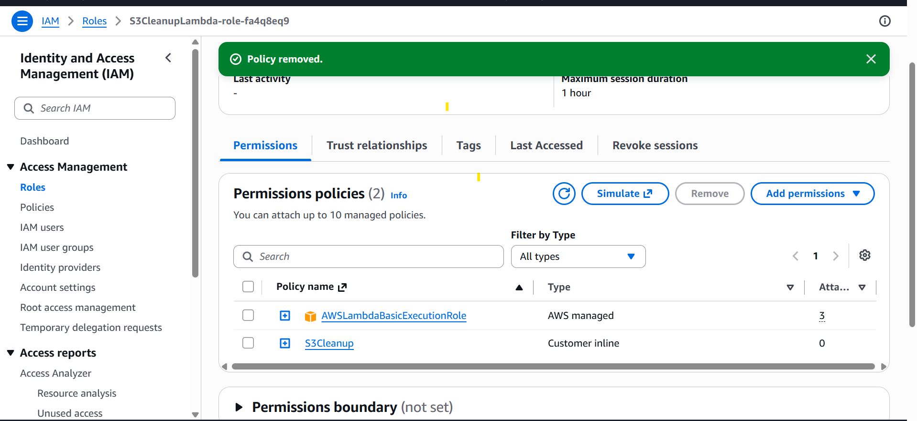

Step 6 – Create Lambda Function
Open
AWS Lambda
Click
Create Function
Choose
Author from Scratch
Name
S3CleanupLambda
Runtime
Python 3.12
Execution Role
Use Existing Role
Select
S3CleanupLambdaRole
S3CleanupLambda-role-fa4q8eq9

Click
Create Function

Step 7 – Lambda Python Code
Replace the default code with:
import boto3
from datetime import datetime, timedelta, timezone

# Replace with your bucket name
BUCKET_NAME = " mys3demo-123456"

# -----------------------------
# Testing
# Change to:
# AGE_THRESHOLD = timedelta(minutes=5)
#
# Production
# AGE_THRESHOLD = timedelta(days=30)
# -----------------------------
AGE_THRESHOLD = timedelta(days=30)

s3 = boto3.client("s3")

def lambda_handler(event, context):

now = datetime.now(timezone.utc)

paginator = s3.get_paginator("list_objects_v2")

deleted = []

for page in paginator.paginate(Bucket=BUCKET_NAME):

if "Contents" not in page:
continue

for obj in page["Contents"]:

last_modified = obj["LastModified"]

if now - last_modified > AGE_THRESHOLD:

s3.delete_object(
Bucket=BUCKET_NAME,
Key=obj["Key"]
)

print(f"Deleted: {obj['Key']}")

deleted.append(obj["Key"])

return {
"statusCode": 200,
"deleted_objects": deleted
}

Why Use a Paginator?
Never assume S3 returns all objects in one response.
list_objects_v2() returns a maximum of 1,000 objects per request.
The paginator automatically retrieves every page, making the function work reliably for buckets of any size.

Step 8 – Deploy
Click
Deploy

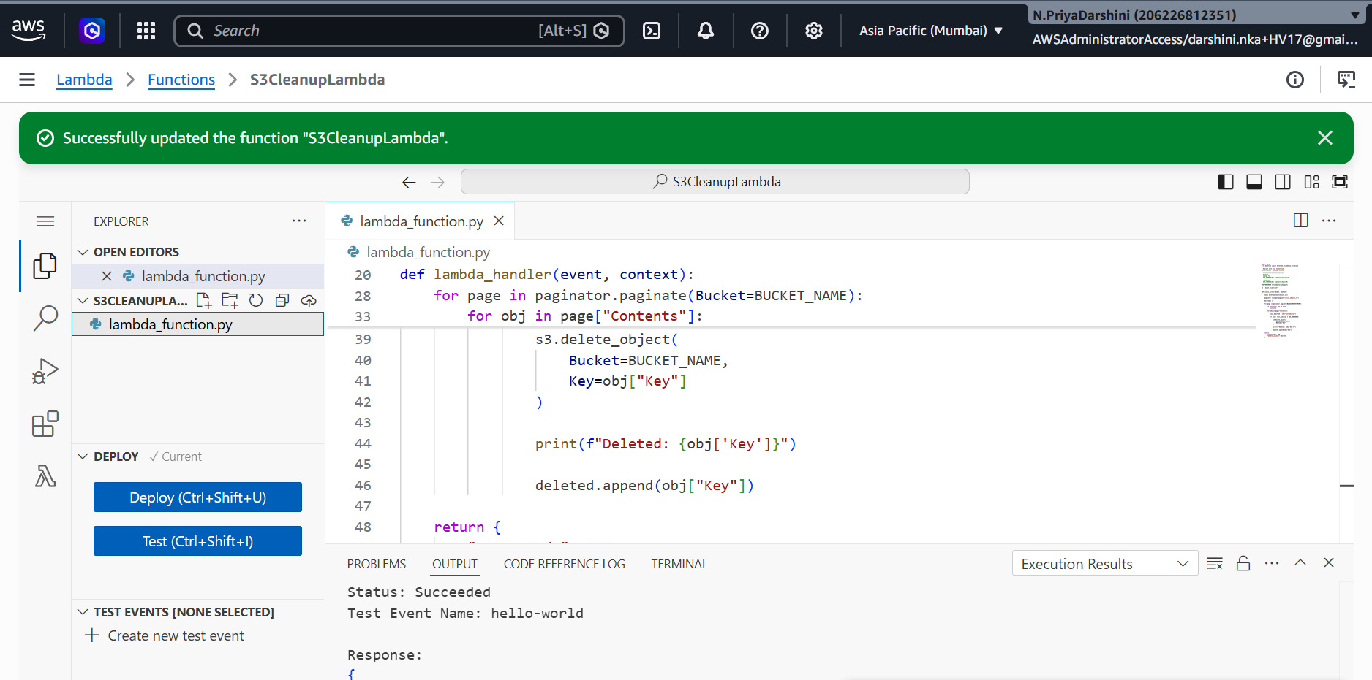

Step 9 – Configure Test Event
Click
Test
Create a new event.
Example:
{}
Save it.

Step 10 – Testing
For testing only:
Modify:
AGE_THRESHOLD = timedelta(minutes=5)
Deploy again.
Wait for some uploaded files to become older than five minutes.
Upload another fresh file.
Example:
old-file.txt
(wait 5+ minutes)
Then upload:
New-file.txt
Run the Lambda.
Expected output:
Deleted: old-file.txt
The newer file should remain.

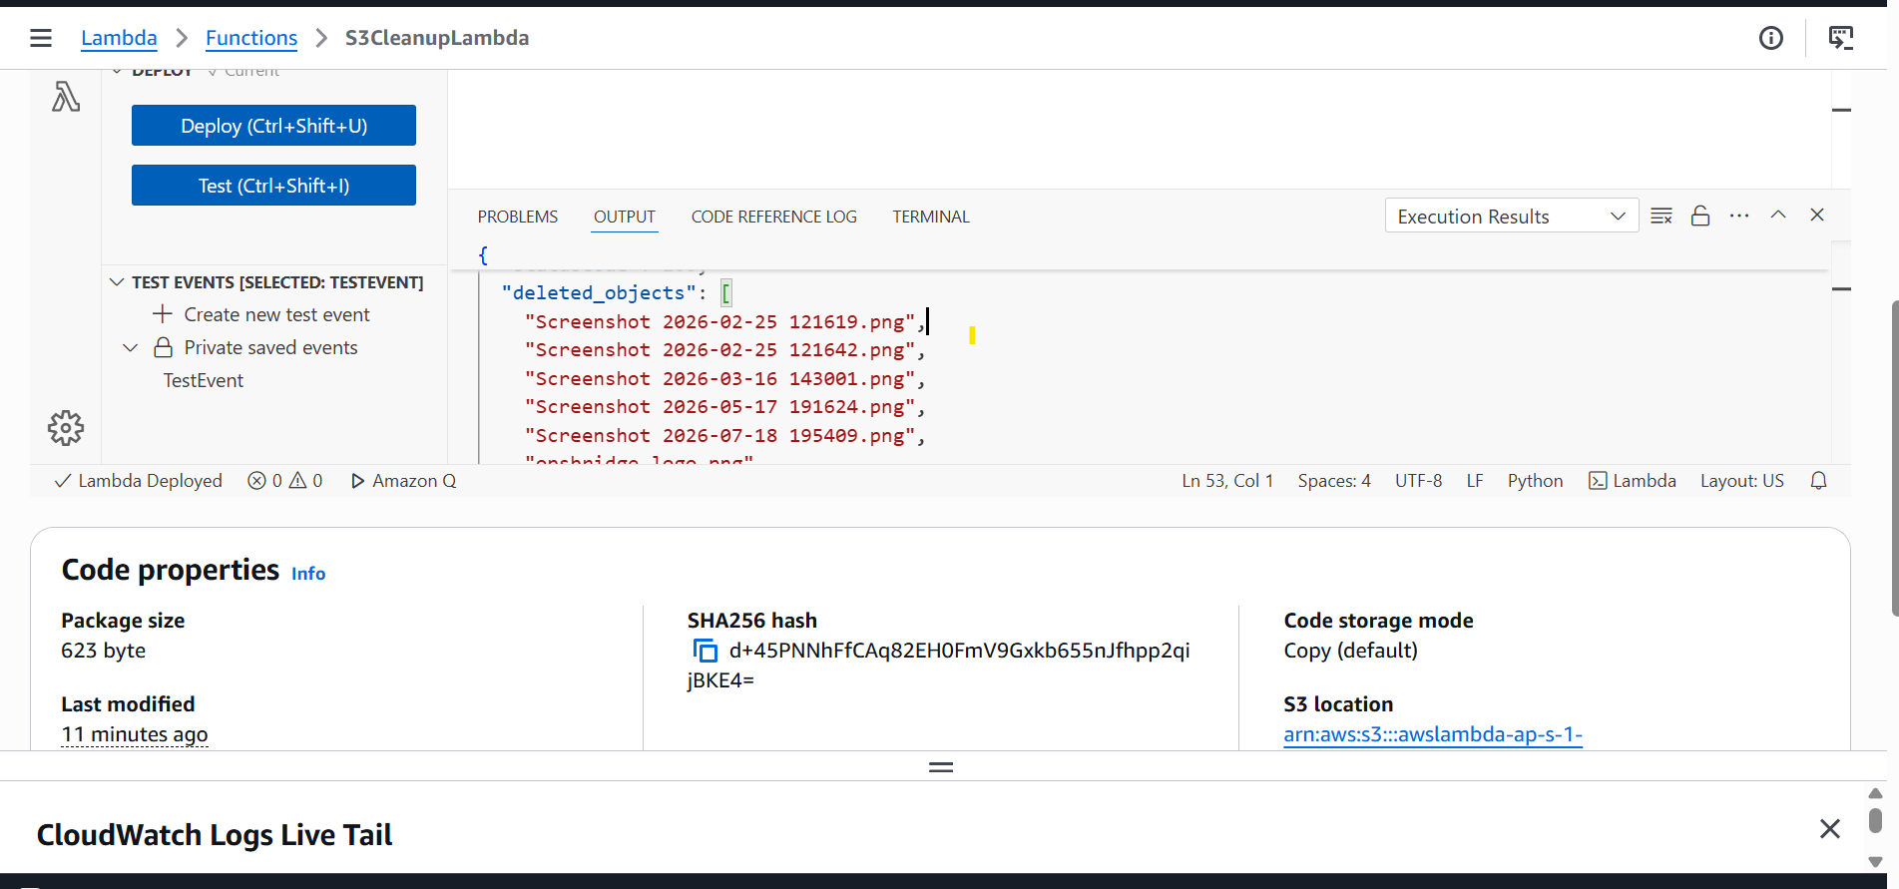

Step 11 – Verify
Open S3 bucket.
Expected:
✔ new-file.txt exists

✘ old-file.txt deleted

Step 12 – View Logs
Open
CloudWatch
→ Log Groups
→ /aws/lambda/S3CleanupFunction
Example log:
Deleted: sample1.txt

Deleted: sample2.txt

Deleted: image.png

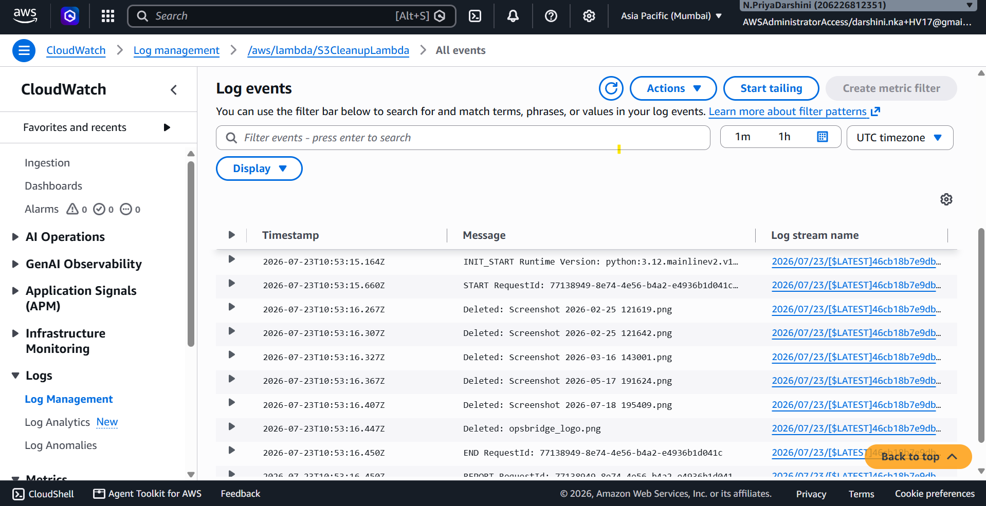

Step 13 – Switch to Production
Change
AGE_THRESHOLD = timedelta(minutes=5)
to
AGE_THRESHOLD = timedelta(days=30)
Deploy again.
The function is now production-ready.

Expected Lambda Output
{
"statusCode": 200,
"deleted_objects": [
"sample1.txt",
"notes.pdf"
]
}
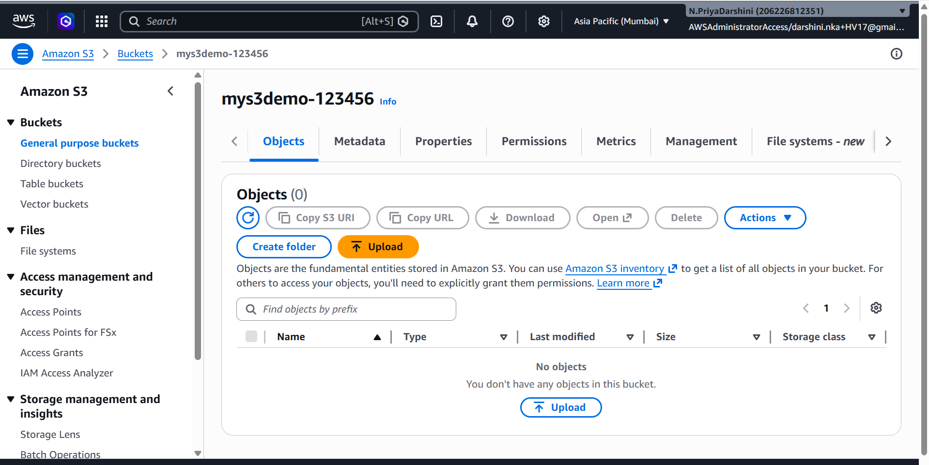

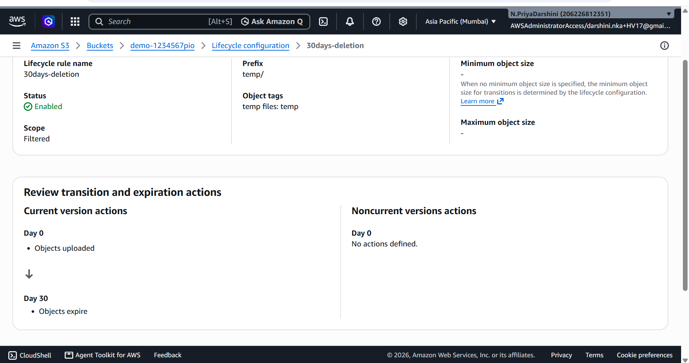

Discussion: S3 Lifecycle Rules vs AWS Lambda for Object Cleanup
In a production environment, Amazon S3 Lifecycle Rules are the recommended solution for automatically deleting stale objects because they are a built-in S3 feature that requires no application code, no Lambda function, and no additional compute cost. Lifecycle rules can automatically transition objects to cheaper storage classes or permanently delete objects after a specified number of days based on object age. They are simple to configure, reliable, and fully managed by AWS.
However, AWS Lambda is useful when the cleanup process requires custom decision-making or actions beyond simple age-based deletion. For example, Lambda can delete objects only when they match specific naming patterns (such as files with a particular prefix), have certain metadata tags, belong to a specific user or application, or meet multiple conditions. Lambda can also perform additional tasks during cleanup, such as sending notifications through Amazon SNS, updating records in a database, creating audit logs, or interacting with other AWS services.
AWS Lambda is used instead of S3 Lifecycle Rules when object deletion requires custom logic or additional processing. For example, Lambda can delete objects based on specific naming patterns, metadata, file types, or multiple conditions rather than only object age. It is also useful when cleanup needs cross-service actions, such as sending notifications, updating databases, or triggering other AWS workflows.

*********************************END***************************************************

